

Best Practices

The Concierge Assistant

Creating an Itinerary

Itineraries can be easily produced for your guests at any time, either individually or with our most recent enhancement, you can print all your outstanding itineraries at once. A guest’s itinerary can encompass their entire stay or can be printed for just the day’s activities. For single events, you may prefer to print a confirmation instead.

Printing an Individual Itinerary

To print an individual itinerary, Select By the “Last Name” under the “Logbook” feature of The Concierge Assistant and click on the icon that looks like a suitcase.

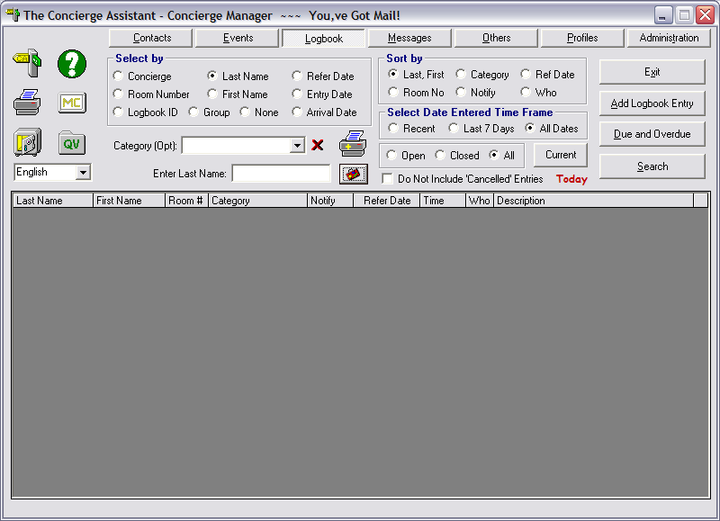

The following screen will be displayed.
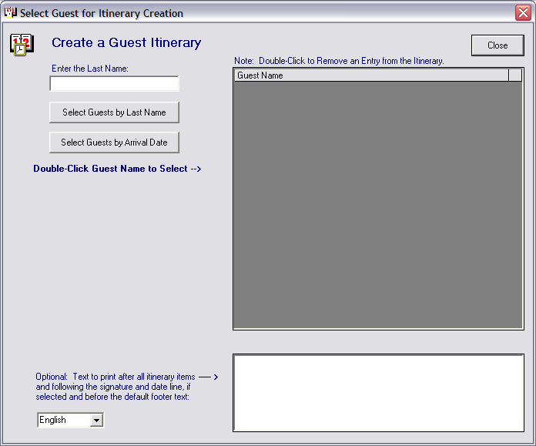

Enter 4 or 5 letters of the guest’s last name and click on the button “Select Guests by Last Name”.

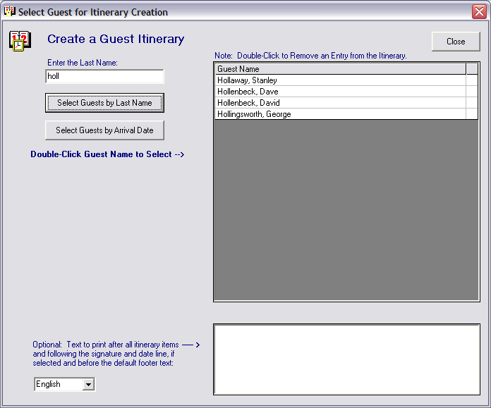

The itinerary display panel will list the guests by last name alphabetically for your selection, as in the example above. Double click on the name of the guest you wish to select.

The following screen will appear listing the guest’s scheduled activities. If the Sequence Time was provided when the logbook entry was established (recommended for multiple requests for the same day), the entries will appear in their proper time sequence. If the time was not provided the entries will appear in alphabetical order.

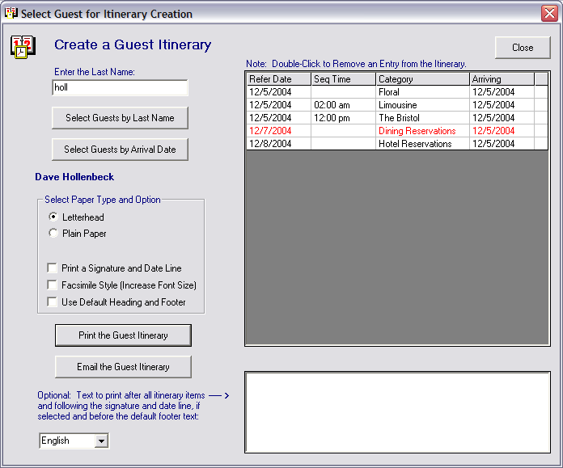

If any of these scheduled events should NOT be displayed on the guests’ itinerary, double click on the item to remove it from the itinerary. This does not delete the entry.
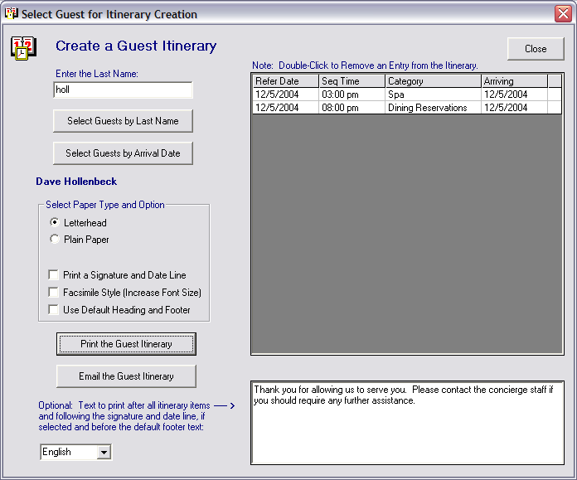
NOTE: If you find that you have removed too many items and you need to recall the transactions, simply click on “Select Guests By Name” and the original listing of guests will return and repeat the steps.

You may make other selections such as the paper, a signature line, increasing the font size or using the “Default Heading and Footer” (established through Administration under “Palm and Print Options” to the tab “Other Palm and Print Options”, click on the button Itinerary Header and Footer Text).
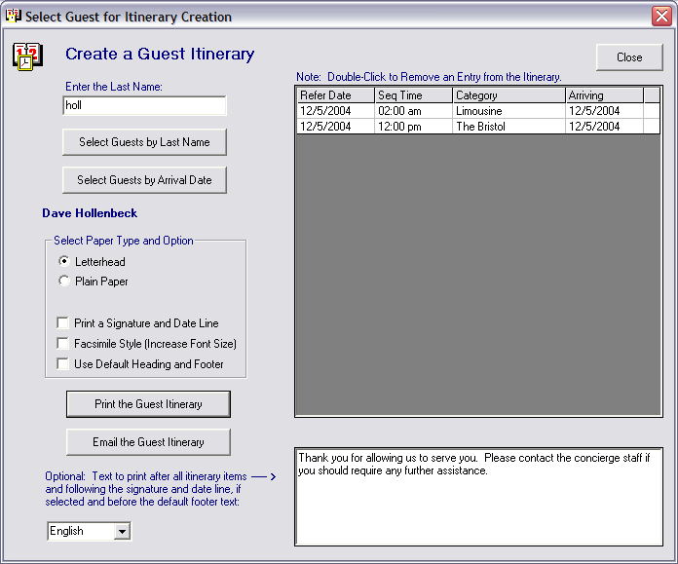

You may also opt to enter a personal note, if desired. The message will only last for the one time and must be reentered for each individual itinerary, if the same message is desired on more than one.

Another option that is available to you is the ability to have portions of the itinerary printed in one of six (6) languages. Please check the Administration tab under “Palm and Print Options”, click on the tab labeled “Other Palm and Print Options” and click on the button labeled Internationalize the Guest Forms. Most properties have the translations in French, German, Portuguese, Italian and Spanish already built into The Concierge Assistant. If you find that the tables in your version are blank, please contact Gold Key Solutions at 818-865-0006 and we will give you the instructions on getting the languages installed in your database.

When the desired options have been selected, click on either the “Print the Guest Itinerary” or the “Email the Guest Itinerary” button.

If the Print button is selected, the following screen will appear. Click on the small printer icon above the viewed document and give to the guest. If your guest has requested an email instead of a fax or letter, you may email this document by clicking on the “Create RTF” button.

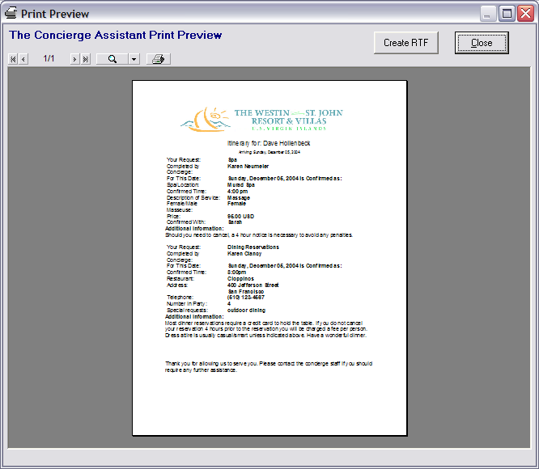

This will create a “Rich Text File” or Word document that you may personalize, restructure or adjust in any manner you desire. If the database in The Concierge Assistant contains a logo graphic that is used as your property’s “Letterhead” and desired on the document, you may use the “shortcut command” for paste (Control key and the “V” key) and the logographic will be pasted to the document. The document can then be saved and sent it as an attachment or it may be sent directly to the guest as it is.

If the Email key is selected, The Concierge Assistant will generate an email utilizing the hotel’s email system (Outlook Express and Microsoft Outlook, in most cases), such as the example. NOTE: If a “Profile” has been created for this guest in The Concierge Assistant and the email address is on record and the Logbook entries have been associated with the “Profile”, CA will automatically populate the email address for you.

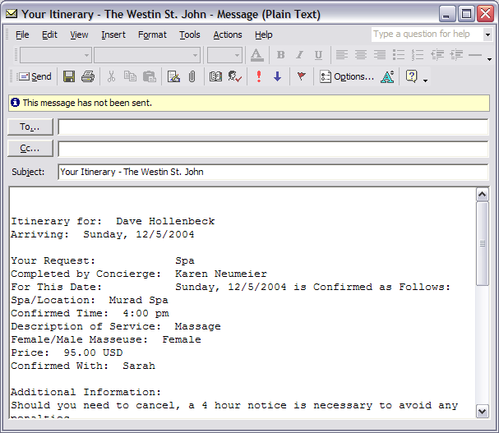

To exit this screen, click on the “Close” button in the upper right hand corner.

Creating Multiple Itineraries

It may be a policy of your property to print all of the guest confirmations and itineraries at one time or you may just want to do it that way. Well, whatever the reason, we decided that it was a great idea so we enhanced The Concierge Assistant to accommodate that procedure.

There are a few things that make this process slightly different than selecting the itineraries one by one. You will not have the ability to “itemize” the itinerary in the same manner to “filter out” those items such as; amenities, flowers, fax copies, etc. that you do not want reflected on the guest’s itinerary. Instead, the “Arrival date” will be the determining factor as to whether the item will be selected for printing. If a logbook entry is NOT to be printed on the itinerary, do NOT fill in the Arrival Date on the Logbook entry when entering it into CA.

First, you will want to Select By the “Last Name”, just like you did for the individual itinerary request, and click on the suitcase icon.

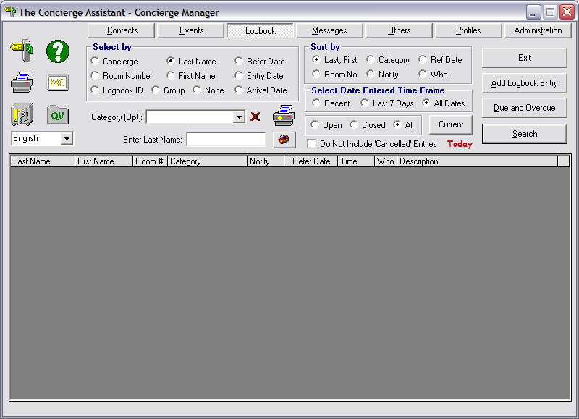

The following screen will appear. Click on the “Select Guests by Arrival Date”

This screen will appear.

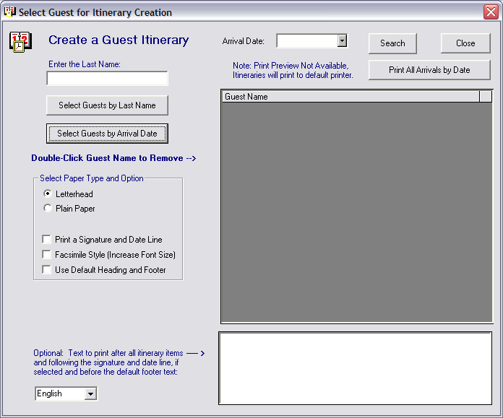

Enter the Arrival Date you wish to print the itineraries for and click on the Search button.
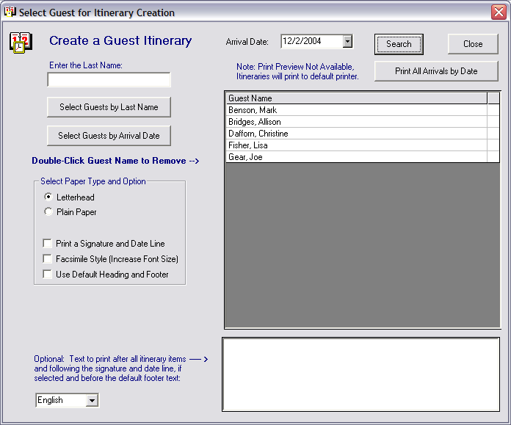

The Concierge Assistant will bring up a listing of guest’s names matching the Arrival Date you entered. Double click on any guest name that you do not want included in the printing with the others.

As with the individual itineraries, you have additional options such as paper selection, printing signature lines, increasing font size and using Default Heading and Footer text (supplied in Administration to Palm and Print Options to “Other Palm and Print Options” to “Maintain Itinerary Header and Footer Text”.

The option of having portions of the itinerary printed in one of six (6) languages is also available. Please check the Administration tab under “Palm and Print Options”, click on the tab labeled “Other Palm and Print Options” and click on the button labeled Internationalize the Guest Forms. Most properties have the translations in French, German, Portuguese, Italian and Spanish already built into The Concierge Assistant. If you find that the tables in your version are blank, please contact Gold Key Solutions at 818-865-0006 and we will give you the instructions on getting the languages installed in your database.

When the guests have been selected just click on the “Print All Arrivals by Date” button. NOTE: There is no print preview with this option. Emailing through the RTF document is not available with the Multiple Itineraries option.

Click on the “Close” button to exit the screens.

